Bash Tool Project Documentation [2019-02-14]

**Purpose**

*This tool was designed to work in conjunction with Puzzle Pirates (a game by Grey Havens). It utilizes Windows Presentation Foundation (WPF) as the Graphical User Interface (GUI) and showcases the ability to read from and analyze a text file, interact with a database to read and write information, and compile and output results to a CSV file.*

*This tool’s purpose is to count up the number of Lavish Lockers (LLs) each pirate is able to take across multiple fights, and compile the results in order to motivate a more competitive environment. The tool also keeps track of the ships encountered and the number of LLs gained during the previous fight with that ship, as there are nuances within the game tied to ship spawns and their associated names. There are multiple configurations throughout the tool that allow for the tying of alternate accounts (abbreviated “alts”) to their main accounts, the locating of the chat logs text file, and whether the tool analyzes the full file or only new incoming lines. These various configurations will be detailed and documented later on.*

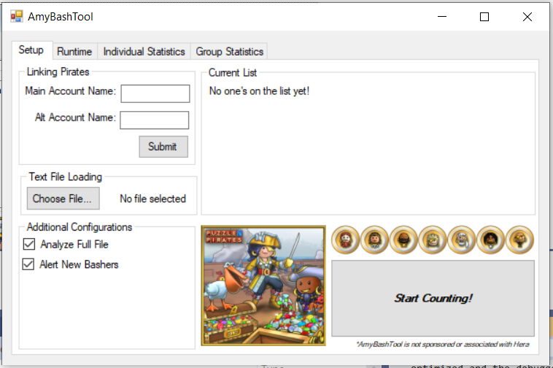

Screenshot 1: Insert Caption Here

**Setting Up**

1. Build Specifications
   1. This tool was developed using Visual Studio 2019 in C#, and further development of the tool should take place under the same settings. It was built under “Debug” and “Any CPU”, and other variants are not guaranteed to work.



Screenshot 2: Insert Caption Here

1. Creating the Bash Tool .EXE
   1. In order to create the .EXE file, open the project within Visual Studio 2019 using “Debug” and “Any CPU” in Screenshot 2. Then, select “Build > Build Solution” via the top bar, and navigate to the project directory by right-clicking the “AmyBashTool” project and selecting “Open Folder in File Explorer”. Lastly, navigate into “bin\Debug” to locate the AmyBashTool.EXE file.

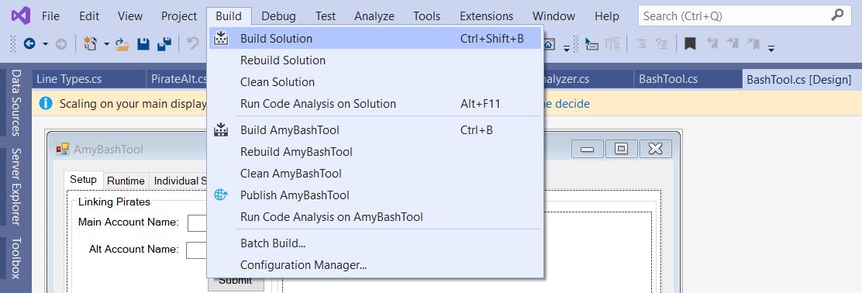

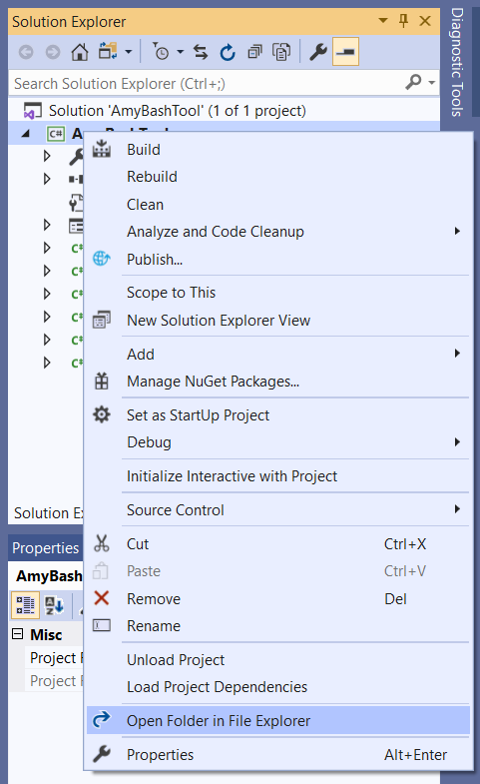

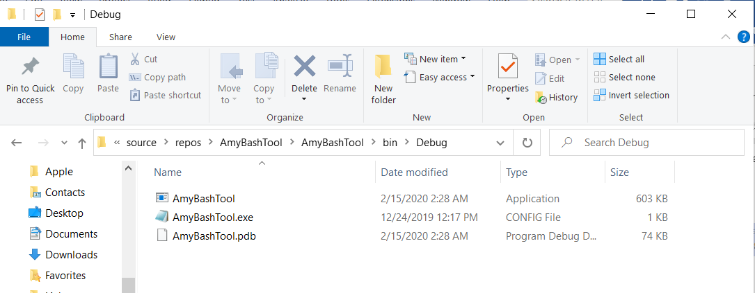

Insert Image and Caption Here

1. Launching the Bash Tool
   1. If launching from Visual Studio 2019, right-click the “AmyBashTool” project within Visual Studio 2019 and choose “Set as StartUp Project”. Then, hit the “Start” button near the upper tabs to launch the application.

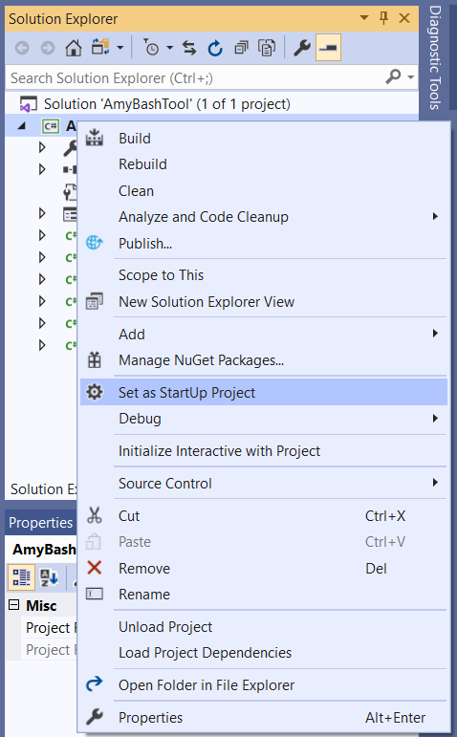



Insert Image and Caption Here

* 1. In order to use the AmyBashTool.EXE file, simply double-click the application and launch.

**Advanced Settings and Usage**

**Note: *This format is for additional information that’s relevant to the entire step, and might need to be referred to again at a later time.***

***Project-Specific IP’s***

**EFP Server IP HERE**

**CRD Web Server IP HERE**

**EFP Workstation IP HERE**

**FBI Simulator Server <Coming Soon>**

**FBI Simulator Client <Coming Soon>**

***Shared IP’s***

**Domain Controller IP HERE**

**Database Server IP HERE**

1. **Additional things within this header portion**

**<Insert Portion> Debugging Help**

* **General Debugging**
  + ***This type of a section is meant for helping out with debugging various things within a header.***
  + ***These should be steps that were necessary to reach this point, but might not have been if things were set up properly to start, or if the computer was wiped before starting.***

**Known Bugs**

* **Bug Name**
  + Bug Description